# PROJECT Deatails

|  |  |
| --- | --- |
|  | **Description** |
| **Project Name** | FATTY ACID BEADS PLANT |
| **Project Description** | 1000 Kg/Hr of Fatty Acid Beads Plant. |
| **Project Manager** | Mr. Pramath Sanghavi |
| **Project team Members** | Anandrao Sangle, Sandip Kundu, Govind Ghule, Sagar Panchal, Satish Jadhav, Rohidas Ninawe, Amit Londhe, Gopal Krishna Sawant, Ravi Sonkamble, Milind Patil, Mahesh Hindlekar, Santosh Sharma, Joseph Sathe, |
| **Supporting team Members** | Dinesh Danav, Ajay Kumbhar, Pravin Patil, Sunil Katekari, Pravin Nerkar, Suryakanth Shabolu, Pratik Mehta, Rayomand Mirzan |
| **Project approved on** | 01.02.2016 |

|  |  |  |  |  |
| --- | --- | --- | --- | --- |
|  | **Baseline** | **Actual** | **Variance** | **% Variance** |
| **Start Date** | 01.02.2016 | 01.02.2016 | 0 | 0 |
| **Finish Date** | 01.11.2016 | 24.09.2016 – 1st Run  26.09.2016 – 2nd Run | (-) 37days | (-) 13.7 |
| **Months** | 09 | 08 | (-) 37days | (-) 13.7 |

**Actual budget Consumtion for Civil**

Distributed budget for Civil work = 3752100/-

Actul consumed budget for services =2409220

Actul consumed budget for Materials =1144427

Total Consumed for Civil work = 3553647/-

Total saving of budget in % = 5.28%

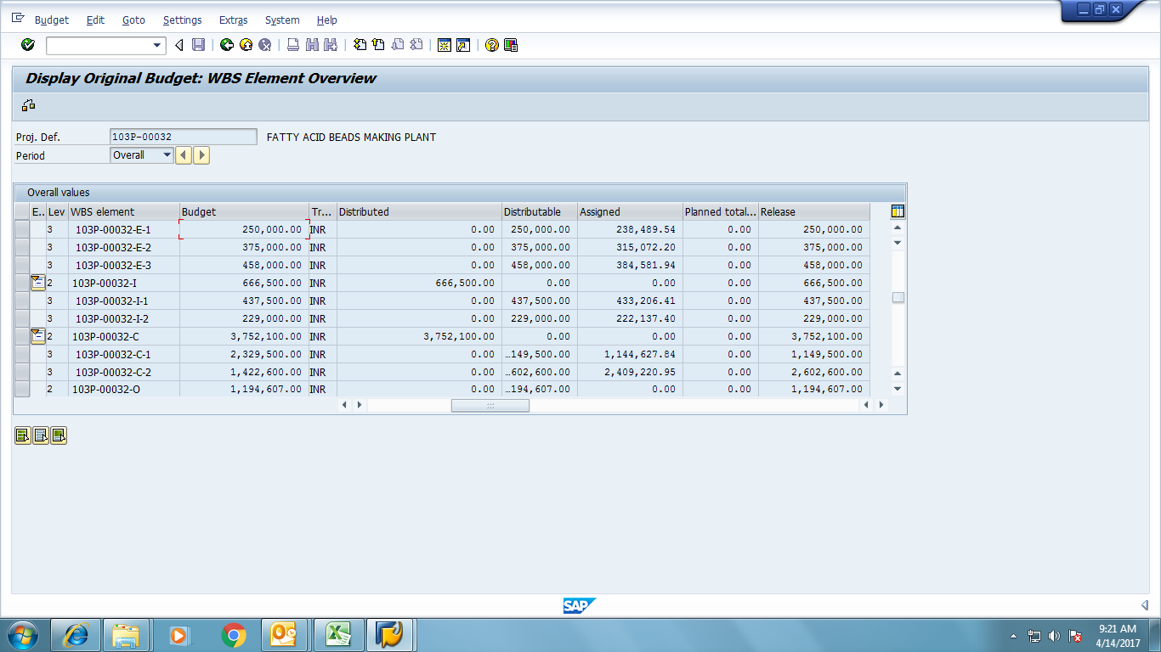

**CERTIFICATE OF STABILITY** Date: 13th Oct, 2016

Form-1A (Rule-3A)

1. Name of Factory : VVF (India) Limited

1. Village, Town, district in

which the factory is situated : Taloja, District Raigad

1. Full Postal address of the factory : Plot No.V-41,MIDC Industrial Area,

Taloja, Dist- Raigad Maharastra-410208.

1. Name of the occupier of the factory : Mr. Rustom G Joshi
2. Nature of manufacturing process

to be carried on in the factory : CPP-7.5 MW Plant

1. Number of floors on which the

workers will be employed : Ground floor+2 (CPP Ground floor  & CPP Control Bldg.)

I certify that, I have inspected the premises, the plans on which have been approved by the Chief Inspector of Factories vide his Letter No. PLN/SMK/R-276/1885/12 Dated 21/3/2012 and examined the various parts including the foundation with special reference to the machinery, plant etc., that have been installed.

I am of the opinion, that all the works of engineering construction in the premises, are structurally sound and their stability will not be endangered by their use as FATTY ACID BEADS PLANT Structure , for which the machinery, plant etc., installed are intended

Signature : Kailas B. Todkari

Qualification : B.E., M.E. (Structures), MIE (Chartered Engineer)

P.M.C. Lic. No. 357; MIE No.: M-144665-1

Address : “AVALON” Flat No. 304, Suncity Road, Sinhgad Road, Pune -411051